CS 224 – LAB 5

3-Stage Pipeline Processor

Student Details
- Name: TODO: Fill
- Roll No: TODO: Fill
- Group Number: TODO: Fill
- Date: TODO: Fill

Please note:
Students must be able to explain the code they submit (whether provided or written by them).
If a student cannot explain a component, marks for that component will not be awarded even if it works.
⚠ No marks will be awarded if the block diagram is not shown.

1. Block Diagram (1.5 marks)
Draw the complete 3-stage pipeline processor architecture. The submission must include:
A. Top level block diagram: Show the full processor pipeline with:
☑ Program Counter (PC)
☑ Instruction Memory
☑ IF + ID Stage
☑ Register File
☑ Execute Stage (ALU)
☑ MEM + WB Stage
☑ Data Memory
All inputs and outputs must be clearly labeled.
B. Individual stage diagrams: Draw separate diagrams for:
☑ IF + ID Stage
☑ Execute (EX) Stage
☑ MEM + WB Stage
Use:
• Combinational blocks: muxes, decoders, adders, comparators
• Sequential blocks: registers, synchronous memories
If you wish to improve or correct previously submitted stage designs, you may do so here.
📌 Both the top-level pipeline diagram and the individual stage diagrams will be evaluated.
Hint: Ensure that block diagrams do not contain combinational loops (e.g., connecting the output of combinational logic directly back to its input).
In particular, carefully check the MUX connections in the Data Memory (D-MEM) path.
TODO: Paste image of top-level pipeline diagram
TODO: Paste image of IF+ID stage diagram
TODO: Paste image of EX stage diagram
TODO: Paste image of MEM+WB stage diagram
2. Timing Diagram (1.5 marks)

Minimal signals to be shown (at least; more signals can be included):
- clk
- pc
- instruction in each pipeline stage (IF+ID, EX, MEM+WB)
- alu_operand_1, alu_operand_2
- stall
- mem_write
- wb_result

Conditions to Demonstrate
☑ Normal pipeline execution
☑ At least one stall scenario
☑ At least one branch scenario
☑ Correct register write-back behavior
☑ Multiple instructions flowing through different pipeline stages
Hint: stall is an internally generated signal (not an external input to the top_fpga module).
You should determine how and when the pipeline generates a stall condition.
📌 Minimum 12 clock cycles required
TODO: Paste image of hand drawn timing diagram

3. Design (1.0 marks)

Verilog Files Used
• pipe.v (contains TODO sections)
• IF_ID.v
• execute.v
• wb.v
• memory.v
• opcode.vh

Design Description
The 3-stage pipeline processor operates as follows:

IF + ID Stage
• Fetches instruction from instruction memory
• Updates the program counter (PC)
• Decodes the instruction opcode
• Reads operands from the register file (done in the pipe.v)
• Generates control signals and immediate values

Execute (EX) Stage
• Performs ALU arithmetic and logical operations
• Calculates branch targets
• Evaluates branch decisions
• Generates memory access addresses

MEM + WB Stage
• Performs data memory read and write operations
• Formats load data (byte / halfword / word)
• Generates store write data and byte enables
• Writes the final result back to the register file

Pipeline Control
• Pipeline stages operate concurrently on different instructions
• Stall logic pauses pipeline execution when necessary
• PC updates are frozen during stall cycles

TODO: Add screenshot of pipe.v code (highlight TODO sections)
TODO: Add screenshot of top_fpga.v modifications

4. Validation Using Simulation (0.5 marks)
Testbench
- tb_pipeline.v

Verification Method
Functional simulation using waveform inspection and logged outputs.

Outputs Observed
- Program Counter
- Register write-back data
- Memory read/write signals
- Stall signals

Cycle-by-Cycle Validation of
☑ Instruction fetch
☑ Instruction decode
☑ Proper register file operation
☑ ALU execution
☑ Memory access
☑ Write-back
☑ Stall behavior working

Result
☑ Simulation completed successfully
☑ Output behavior matches expectations
TODO: Paste waveform screenshot here

5. FPGA Demo (2 marks)

Hardware Used
- Nexys A7 FPGA Board

Files Used
- top_fpga.v
- pipe.v
- constraints.xdc / led.xdc

FPGA Mapping
- Clock → On-board 100 MHz clock (via divider)
- Write-back data or PC → LEDs
- Optional slow clock for visibility

Observation
☑ Bitstream generated
☑ FPGA programmed
☑ Pipeline execution visible on LEDs
☑ Continuous instruction flow observed
☑ PC increments correctly
☑ Stable execution without glitches
TODO: Add screenshot of constraints.xdc modifications
TODO: Add FPGA board screenshot showing LED output

6. Bug Identification (0.5 mark)

Bug Identified / Explained / Fixed

TODO: Briefly describe the bug identified during evaluation
☑ Bug correctly identified
☑ Explanation and fix provided

7. Running Programs on the Pipeline (0.5 Marks)

Programs Executed
Program | Command | Status  (Working / not working)
Addition | make addition | TODO: Fill status
Negative subtraction | make negative | TODO: Fill status
Sorting | make sort | TODO: Fill status

TODO: Insert screenshots of the terminal for each program

8. Pipeline And Resource Observation (0.5 mark)
Answer the following based on waveform analysis.
Program | Clock Cycles to Complete | Max Instructions in Pipeline
Addition | TODO: Fill Count | TODO: Fill Count
Negative subtraction | TODO: Fill Count | TODO: Fill Count
Sorting | TODO: Fill Count | TODO: Fill Count

For the “addition“ workload, identify one cycle where multiple stages are active.
TODO: Answer
Obtain resource utilization from the synthesis report:
(see <project_name>.runs/synth_1/top_fpga_utilization_synth.rpt)

LUT | BRAM | Flip flops
TODO: Fill Count | TODO: Fill Count | TODO: Fill Count

9. Additional Workloads (1.0 mark)
Additional C programs executed:
Example programs:
• Fibonacci
• XOR operations
Command used:
make <program_name>
Result:
TODO: Insert screenshots of the terminal output

10. Marking Data and Control Signals (1.0 mark)
Mark the data values and control signals on the provided pipeline datapath diagram for the following instructions.
Assume:
R1 = 1, R2 = 2, R4 = 4, R7 = R6
Instructions:
ADD R3, R2, R1
TODO: Suitably annotate the diagram

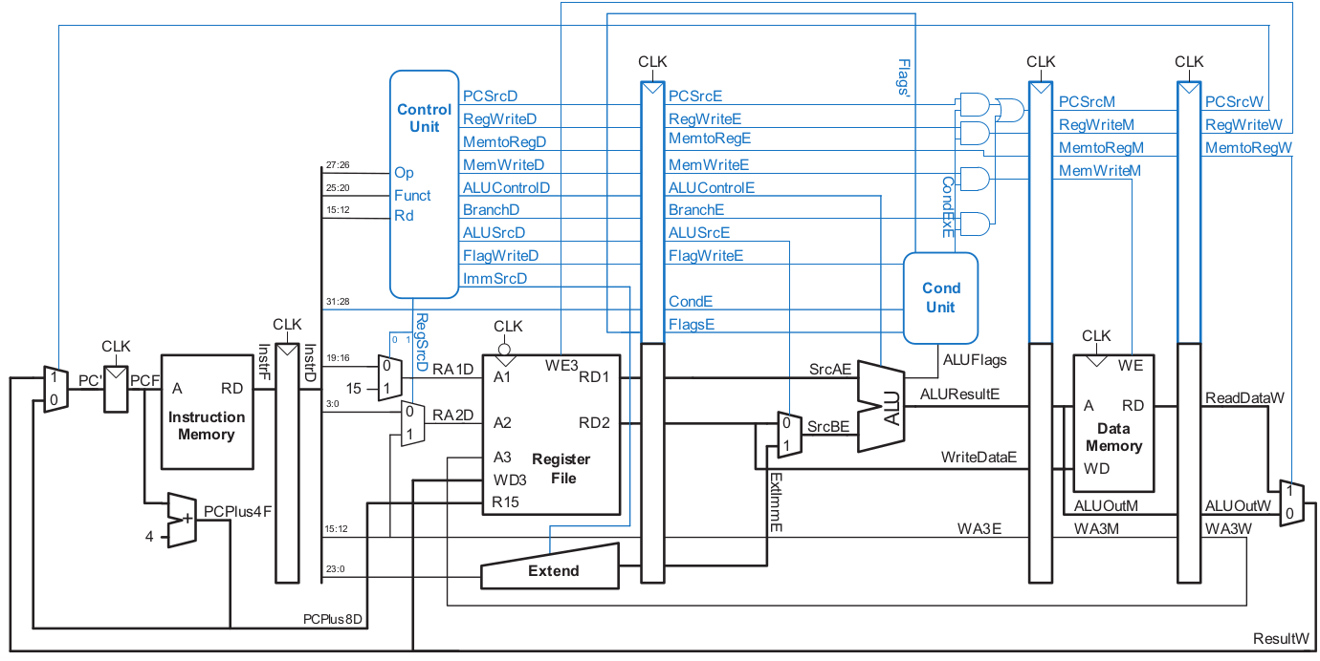

LW R5, R4, [100]
TODO: Suitably annotate the diagram



BEQ R7, R6, [200]
TODO: Suitably annotate the diagram



